**Questions**

1. What is the smallest memory object that can represent a character of information?
   1. Think… How many upper case letters in the alphabet (A to Z)?

There are 26 upper case letters in the alphabet

* 1. Think… How many lower case letters in the alphabet (a to z)?

There are 26 lower case letters in the alphabet.

* 1. Think… How many number digits (0 to 9)?

There are 10 digits

* 1. Think… How many punctuation marks?

There are 14 punctuation marks.,

* 1. Add them all up

There are 76 total.

1. Research the ASCII characters set. What is it and how is it related to computer memory?  
   Every character on the keyboard has its equal binary value. The decimal equal to that binary value is called ASCII (American standard code for information interchange) value. Say for example equal binary value to character 'A' is 01000001, the decimal equal to which is 64.
2. How are strings of characters (Google “String”) represented in computer memory?

Characters are normally represented as strings of seven bits each in an encoding called ASCII (American Standard Code for Information Interchange).

1. How are negative integers represented in computer memory? (Include a diagram)  
   The C standard doesn't mandate any particular way of representing negative signed numbers. In most implementations that you are likely to encounter, negative signed integers are stored in what is called two's complement. ... The one's complement of an N-bit number x is defined as x with all its bits flipped, basically.

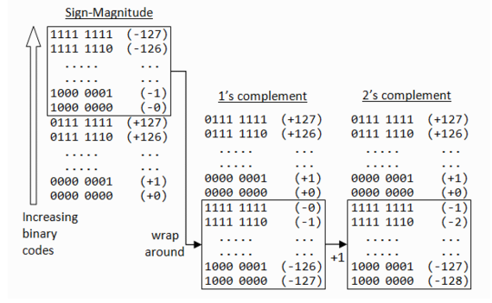

1. How are decimal numbers (Google “Floating Point”) represented in computer memory? (Include a diagram)

The computer memory is organized into strings of bits called words of same length. Decimal numbers are first converted into their binary equivalents and then are represented in either integer or floating point form. Here in an extra zero to the left of the binary number is appended to indicate that it is positive.

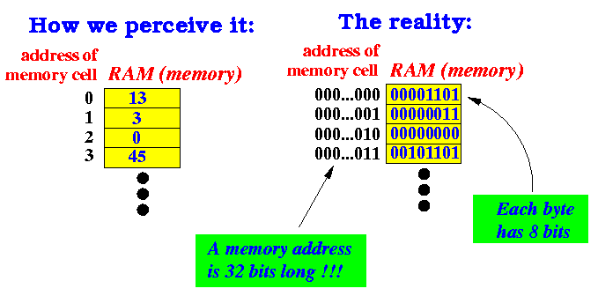

1. A Pixel is computer memory structure used to store image information. How is a Pixel represented in memory? (Include a diagram).

Pixels are the smallest individual element in an image, holding antiquated values that represent the brightness of a given color at any specific point. Typically, the pixels are stored in computer memory as a raster image or raster map, a two-dimensional array of small integers.

